SWINBURNE VIETNAM
HO CHI MINH CAMPUS


COS30018 - COS30018-Intelligent Systems
Week 11: Task C.6

INSTRUCTOR: MR. KY TRUNG PHAM
STUDENT NAME: LÊ TIẾN DŨNG-SWS00683

HO CHI MINH CITY – MAR-2026

Contents
1. Overview 3
2. Implementation Summary 3
2.1 Ensemble components 3
2.2 Key functions added for Task C.6 3
3. Less Straightforward Code Lines 4
3.1 SARIMA parameters and fitting 4
3.2 Aligning DL and SARIMA predictions to the same horizon 4
3.3 Weighted ensemble and why weights matter 5
3.4 Metrics used for comparison 5
4. References Used 5
5. Experiment Results Summary (Multistep / Multivariate / Combined) 5
5.1 Different ensemble configurations (DL type + SARIMA params) 5
5.2 Best-performing configurations (summary) 6
5.3 Comparison table (Best config per weight run) 6

1. Overview

In Task C.6 (v0.5), the objective is to improve forecasting robustness by using an ensemble approach that combines:
- a statistical time-series model (SARIMA via statsmodels) and
- a deep learning model (LSTM/GRU/RNN from my dynamic builder in Task C.4).
I implemented a workflow that trains the deep learning model on the training set, fits SARIMA on the training Close series, produces forecasts on the same test horizon, and then combines the two predictions using a weighted ensemble:
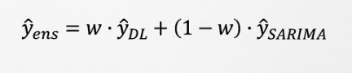
I then ran multiple experiments across different DL model types, SARIMA hyperparameters, and ensemble weights.

2. Implementation Summary

2.1 Ensemble components
- Deep Learning (DL): built using my dynamic function build_recurrent_model(layer_name, num_layers, units, ...) so I can swap between LSTM / GRU / RNN without rewriting training code.
- SARIMA: fitted using SARIMAX from statsmodels, which supports both ARIMA and seasonal ARIMA through (p,d,q) and (P,D,Q,m) parameters.
- Ensemble: computed using a weighted average controlled by w_dl

2.2 Key functions added for Task C.6
I implemented these helper functions:
- fit_sarima(train_close, order, seasonal_order) — fit SARIMA model on training Close series
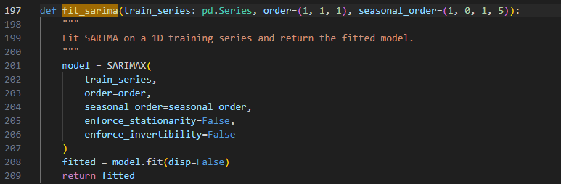
- forecast_sarima(fitted_model, steps) — forecast the test horizon length
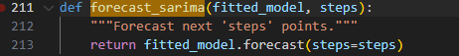

- ensemble_weighted(pred_dl, pred_sarima, w_dl) — combine predictions
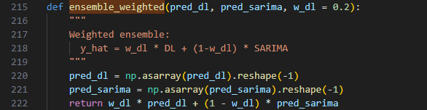
- regression_metrics(y_true, y_pred) — compute MAE/MSE/RMSE consistently across models.
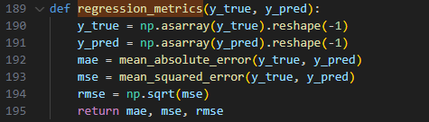

3. Less Straightforward Code Lines

3.1 SARIMA parameters and fitting
Non-trivial part: understanding order=(p,d,q) and seasonal_order=(P,D,Q,m) and choosing a reasonable m.
- order=(p,d,q) controls the autoregressive terms, differencing, and moving average terms.
- seasonal_order=(P,D,Q,m) controls the seasonal AR/DIFF/MA behavior and the seasonal period length m.
- I used m=5 to represent a weekly trading cycle (5 trading days).
Why fit only on training:
To avoid data leakage, SARIMA is fitted only on the training Close series and then used to forecast the test horizon.

3.2 Aligning DL and SARIMA predictions to the same horizon
A key requirement for ensembling is that both models forecast the same timestamps and output vectors of the same length. In my implementation:
- DL produces one prediction per test sample (single-step forecasting in C.6).
- SARIMA forecasts exactly len(test) steps.
- Both are evaluated against the same ground truth vector.

3.3 Weighted ensemble and why weights matter
Instead of assuming 0.5 always works, I experimented with w_dl = 0.2, 0.5, 0.8:
- If SARIMA is worse than DL, a higher w_dl usually improves ensemble accuracy.
- These experiments demonstrate that ensemble performance is sensitive to weight selection.

3.4 Metrics used for comparison
Since the output is a continuous price, I evaluated models using:
- MAE (interpretable in price units)
- MSE and RMSE (penalize larger errors more).
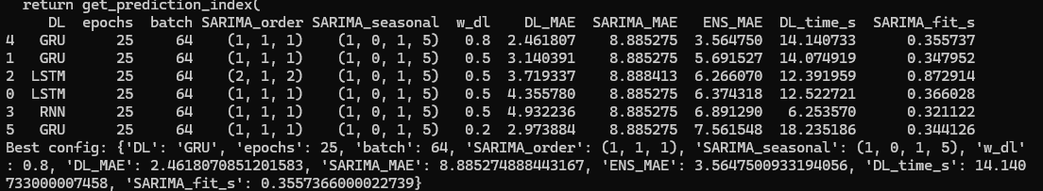

4. References Used
- statsmodels SARIMAX / SARIMA documentation:
https://www.statsmodels.org/stable/generated/statsmodels.tsa.statespace.sarimax.SARIMAX.html
- ARIMA/SARIMA concepts (p,d,q and seasonal P,D,Q,m):
https://www.statsmodels.org/stable/tsa.html
- Keras recurrent layers (LSTM/GRU/RNN behavior, return_sequences):
https://www.tensorflow.org/api_docs/python/tf/keras/layers/LSTM

https://www.tensorflow.org/api_docs/python/tf/keras/layers/GRU

https://www.tensorflow.org/api_docs/python/tf/keras/layers/SimpleRNN

5 Experiment Results Summary (Ensemble configurations & weights)

5.1 Different ensemble configurations (DL type + SARIMA params)
I tested ensemble configurations using:
- DL types: LSTM / GRU / RNN
- SARIMA orders: (1,1,1) and (2,1,2)
- seasonal order fixed to (1,0,1,5)
- ensemble weights: w_dl varied
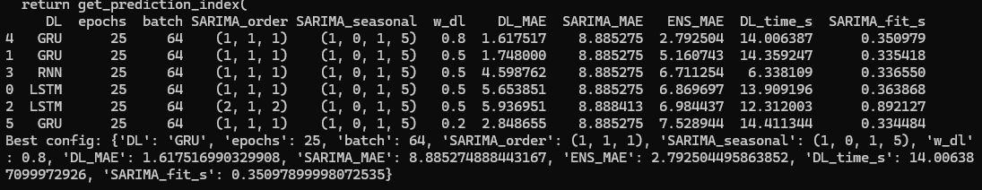
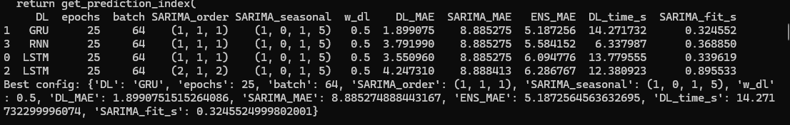

5.2 Best-performing configurations (summary)
Key observations:
- SARIMA alone produced much higher error (MAE ≈ 8.885), so DL dominated performance.
- GRU produced the lowest DL_MAE among tested DL models.
- Increasing w_dl improved ensemble MAE because SARIMA was weaker than DL.

5.3 Comparison table (Best config per weight run)
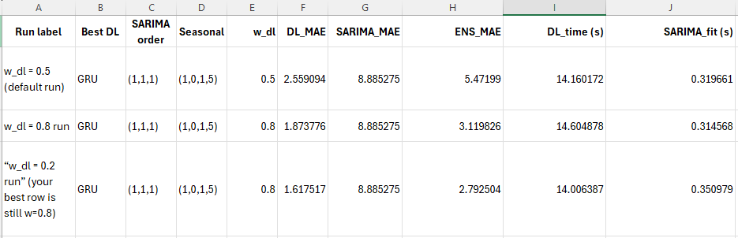
Final best ensemble (lowest ENS_MAE):
- DL: GRU
- SARIMA: (1,1,1) seasonal (1,0,1,5)
- w_dl = 0.8
- ENS_MAE ≈ 2.7925

6. Conclusion
Task C.6 successfully implemented ensemble forecasting by combining a statistical model (SARIMA) with deep learning models (LSTM/GRU/RNN). Experiments show that ensemble performance depends strongly on the ensemble weight and the relative accuracy of each component model. In my experiments, GRU was the strongest DL model, and increasing w_dl improved ensemble results because SARIMA had higher error.Close).

